Connecting to the Wi-Fi Manually

This method works for the ISU-OIT-WPA and ISU-SECURE wireless networks if attempting to connect regularly does not return results.

ON WINDOWS 7, 8 and 10:

1. Open up the Network and Sharing Center located in the System Tray (The toolbar typically in the bottom right-hand corner)

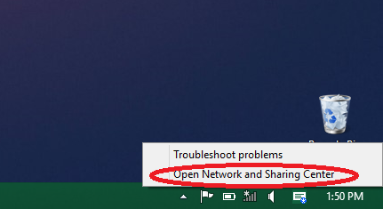

1. Click on the “Manage Wireless Networks” on the left-hand side of the window.
   1. If this option is not available (specifically in Windows 10) open the command prompt and type in netsh wlan delete profile name=”ISU-SECURE” or ISU-OIT-WPA if that is the network you are connecting to.
2. If any ISU Network is in the list, remove it as it can potentially cause issues with setting up and using other ISU networks.
3. Go back to the Network and Sharing Center and Click “Set up a new connection or network”

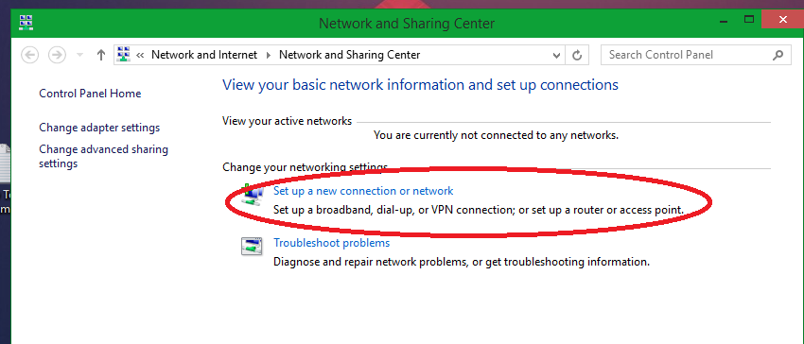

1. Click “Manually connect to a wireless network”

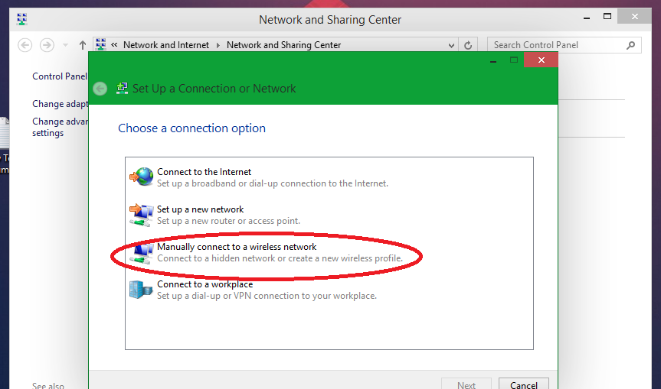

1. Enter in information about the network
   1. Network Name: ISU-OIT-WPA or ISU-SECURE depending on which you are setting up
   2. Security Type: WPA2-ENTERPRISE
   3. Everything else should fill in what is needed correctly so we will move on

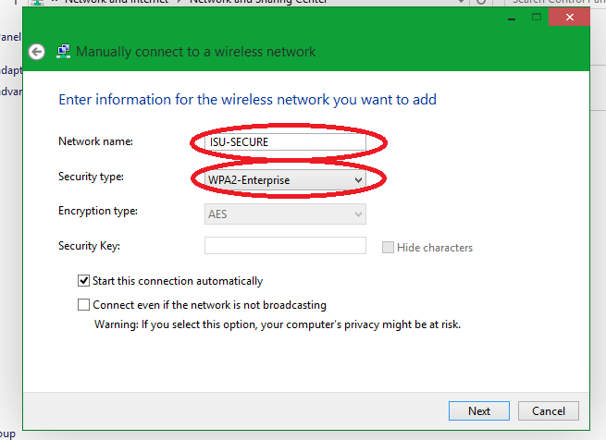

1. Click on “Change connection Settings”

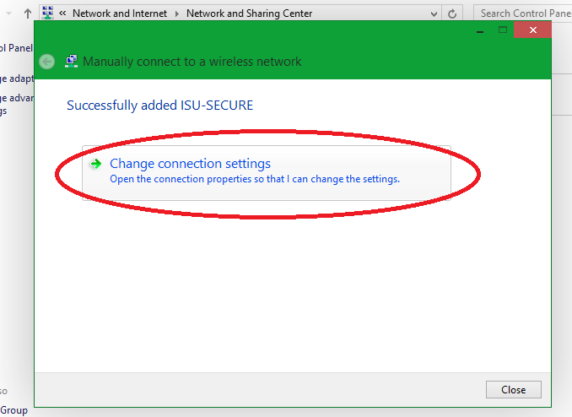

1. Open the Security Tab

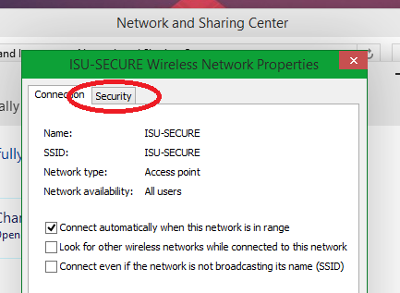

1. Make sure the Network Authentication Method is “Microsoft: Protection EAP (PEAP)” and click “Settings” next to it.

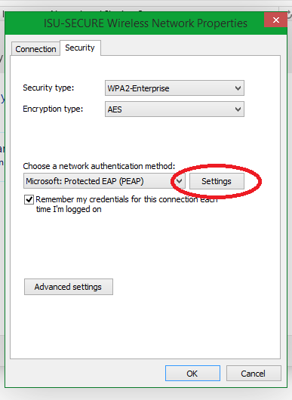

1. Uncheck “Verify the server’s identity by validating the certificate”
2. Make this authentication method “Secured Password (EAP-MSCHAP v2) and click the “Configure…” Button

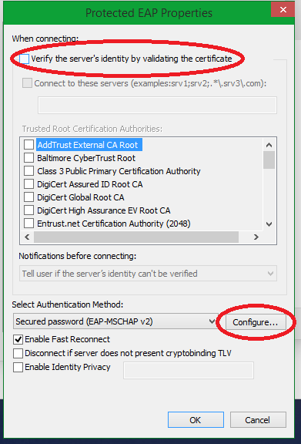

1. Uncheck “Automatically use my windows logon name and password” and click “ok”

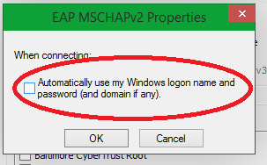

1. Click “OK” again.
2. Click “Advanced settings”

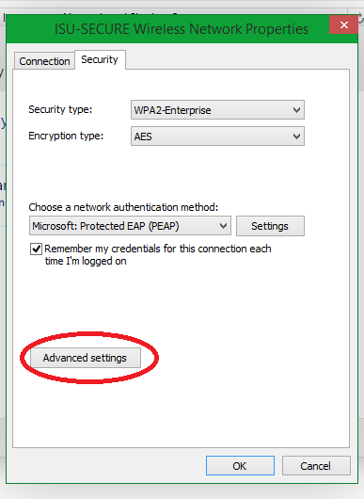

1. Check the “Specify Authentication Mode” and Select User Authentication. You can save credentials her by clicking the button, however not doing so will prompt the user when connecting to enter credentials. When done Click “OK” twice.

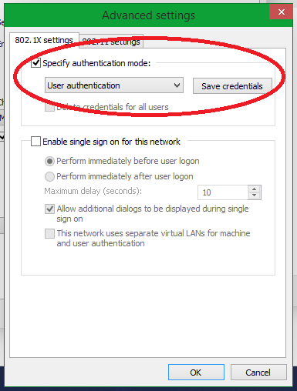

1. If it doesn’t connect immediately, go ahead and click it in the Wi-Fi selection and it will connect.

ON MAC:

1. Click on the Wi-Fi icon on the top left-hand corner of the screen and it should pull up the selection menu.

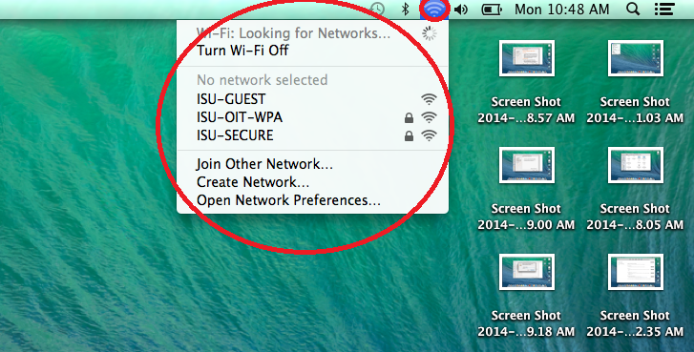

1. Clicking on the selected network will prompt you for the portal credentials followed by the computers login information.

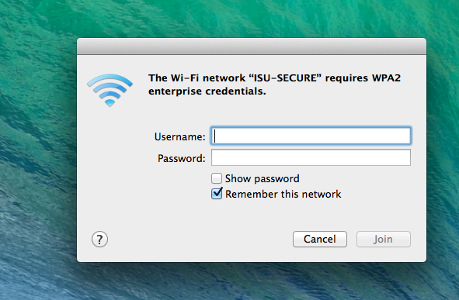

1. If this fails or doesn’t prompt you, you may need to remove the network for the system.
2. You will start by going back to the Wi-Fi icon and clicking on “Open Network Preferences…”
3. Click on Advanced

